IDEATION PHASE – DOCUMENT 3:

EMPATHY MAP CANVAS
Date | 05 November 2025
Team ID | NM2025TMID03595
Project Name | Garage Management Application
Maximum Marks | 4 Marks

Title: Empathy Mapping for “Garage Management Application – A Salesforce-Based Workshop Automation System”

1. Objective
The goal of this empathy mapping phase is to understand the needs, emotions, and challenges faced by stakeholders in a garage environment — including owners, mechanics, and customers.
By mapping what each user says, thinks, does, and feels, the system can be designed with empathy, focusing on simplicity, accuracy, and real-time automation using Salesforce CRM tools.

2. Stakeholders Identified
The empathy map focuses on three primary user personas in the Garage Management ecosystem:
Persona | Role | Goal | Pain Points
Garage Owner / Manager | Oversees operations and staff | Improve service efficiency and maintain accurate records | Manual record-keeping and lack of data visibility
Mechanic / Technician | Performs maintenance and repair services | Complete assigned tasks efficiently | No proper tracking or task scheduling system
 | Requests and receives services | Quick, transparent, and reliable service | No service tracking and unclear billing details
  Customer / Vehicle Owner

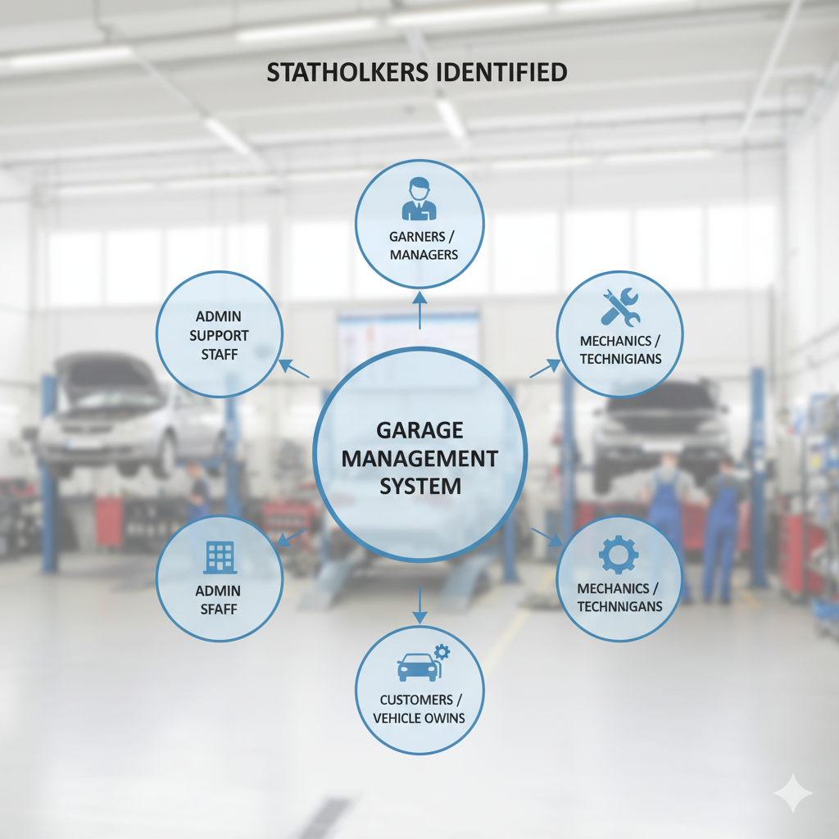

3. Empathy Map Canvas Layout
Below is the empathy mapping framework applied to all four personas.
Quadrant | Description | Key Insights
SAYS | What users express during discussions or observations | “It’s hard to keep track of multiple appointments and services.”
THINKS | What users think internally but may not express openly | “If we had an automated system, managing customers would be easier.”
DOES | Actions or behaviors the users currently perform | Write records manually, call customers for updates, track payments in notebooks
FEELS | Emotional state, frustrations, and expectations | Garage owners feel overworked; mechanics feel unorganized; customers feel uncertain about progress

4. Empathy Map Analysis
From the empathy mapping exercise, several patterns were identified:
- Operational Overload: Garage owners handle too many manual tasks, leading to delays and mistakes.
- Workflow Gaps: Mechanics lack structured task tracking and clear communication on assigned work.
- Customer Uncertainty: Clients are unsure about service timelines and billing accuracy.
Salesforce offers the perfect ecosystem to solve these problems through Custom Objects, Flows, Validation Rules, and Reports.

5. Insights Derived
From From the empathy analysis, the following key insights were derived:
• Automation reduces errors – Salesforce Flows can handle repetitive updates and notifications.
• Transparency builds trust – Real-time service and payment status improve customer satisfaction.
• Ease of use increases adoption – A simple, tab-based Lightning App encourages daily use by staff.
• Performance visibility motivates employees – Dashboards showing service completion rates improve accountability.
• Data ensures consistency – Reports keep managers informed and prevent data loss.

6. Design Implications for FoodConnect
The empathy findings directly influenced the Salesforce design decisions:
Insight | Design Decision
Lack of organized workflow | Created objects for Customer, Appointment, Service Record, and Billing
Need for real-time updates | Implemented Record-Triggered Flows
Transparency requirement | Designed Reports and Dashboards for all service data
Employee accountability | Used Roles and Profiles to track tasks per user
Customer satisfaction | Added Feedback and Rating fields

7. Empathy Map Canvas Summary
The empathy mapping phase revealed that the success of the Garage Management Application lies in simplifying operations for garage owners while improving service visibility customers.
Using Salesforce CRM, the application turns manual, time-consuming processes into automated, trackable, and transparent workflows that enhance trust, speed, and overall satisfaction.
Salesforce tools like Flow Builder, Reports, and Dashboards enable garages to:
- Deliver efficient and accurate services.
- Build long-term customer relationships.
- Make data-driven business improvements.
In essence, empathy-driven design transformed the Garage Management System from a simple digital tool into a complete operational solution.

